**

**LOVING**

**Learning Theory**

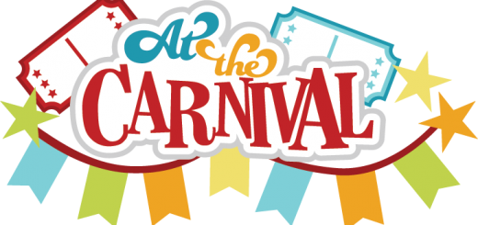

**New Student Center**

**7:15-9:30pm**

**Monday, July 22, 2019**

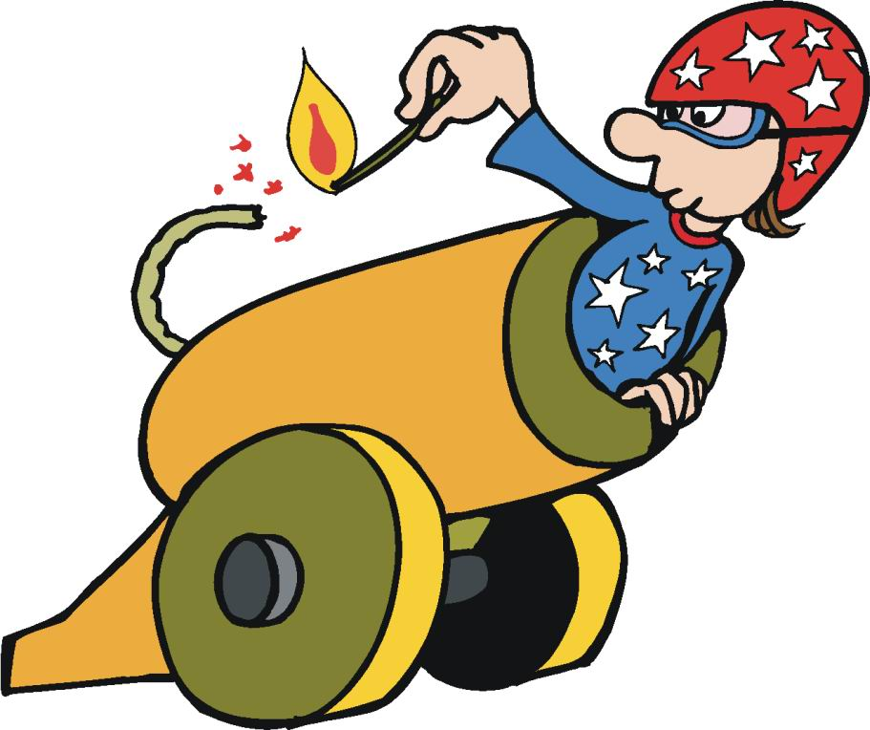

“***Education is not the filling of a pail,***

***but the lighting of a fire.”***

*-William Butler Yeats*

What’s learning theory got to do with it?

ABSOLUTELY EVERYTHING

The purpose of the “loving learning theory carnival” is to provide an interactive process for reviewing what you know about learning theory

and its importance in classrooms.

**Logistics.** We expect to have 80 participants and the teaching team and coach-facilitators who could offer support at booths with teaching team. There are **four rotations.** After the opening revue and the directions with, we are proposing you visit four of the eight booths. At each booth, there should be about 10 people at a time. At each booth, you receive stamp for your Loving Learning Theory packet.

**Teaching Team Revue: “What’s learning theory got to do with it?”**

**Learning Theory Overview**

**Possible video overview**

<https://www.youtube.com/watch?v=NcznYMK6r_8>

Constructivism Video of about 4 min.

**Round Times**

**Each of you with a partner go to 4 booths,**

**not all 8. The booths you go to are on your small notetaking booklet. You will get a “stamp” at each booth.**

|  |  |
| --- | --- |
| 7:15-7:35 | Overview, Revue & Directions |
| 7:35-7:50 | **Round One** |
| 7:50-8:00 | Walk and Talk between booths with partner |
| 8:00-8:15 | **Round Two** |
| 8:15-8:25 | Walk and Talk between booths with partner |
| 8:25-8:40 | **Round Three** |
| 8:40-8:50 | Walk and Talk between booths with partner |
| 8:50-9:10 | **Round Four** |
| 9:10-9:30 | Debrief All |

REVUE by the

PROJECT I4 TEAM

|  |  |
| --- | --- |
| Tina Turner lyrics | **REVISED PROJECT I4 LYRICS** |
| [You must understand though the touch of your hand Makes my pulse react](https://genius.com/Tina-turner-whats-love-got-to-do-with-it-lyrics#note-4735128) That it's only the thrill of boy meeting girl Opposites attract It's physical Only logical You must try to ignore that it means more than that  [Chorus] [What's love got to do, got to do with it?](https://genius.com/Tina-turner-whats-love-got-to-do-with-it-lyrics#note-4735147) What's love but a second-hand emotion? [What's love got to do, got to do with it? Who needs a heart when a heart can be broken?](https://genius.com/Tina-turner-whats-love-got-to-do-with-it-lyrics#note-4579344)  [Verse 2] [It may seem to you that I'm acting confused](https://genius.com/Tina-turner-whats-love-got-to-do-with-it-lyrics#note-4735166) When you're close to me [If I tend to look dazed I've read it someplace I've got cause to be There's a name for it](https://genius.com/Tina-turner-whats-love-got-to-do-with-it-lyrics#note-4735173) [There's a phrase that fits But whatever the reason you do it for me](https://genius.com/Tina-turner-whats-love-got-to-do-with-it-lyrics#note-4735183)  [Chorus] What's love got to do, got to do with it? What's love but a second-hand emotion? What's love got to do, got to do with it? Who needs a heart when a heart can be broken?  Bridge  I've been taking on a new direction But I have to say I've been thinking about my own protection It scares me to feel this way  [Chorus] What's love got to do, got to do with it? What's love but a second-hand emotion? What's love got to do, got to do with it? Who needs a heart when a heart can be broken?  [Chorus] What's love got to do, got to do with it? What's love but a sweet old-fashioned notion? What's love got to do, got to do with it? Who needs a heart when a heart can be broken?  [Chorus] What's love got to do, got to do with it? What's love but a second-hand emotion? | You must understand that the pulse in my brain  Makes synapses react  That it’s only the thrill of an amygdala chill  That’s a learning pill  It’s electrical  Only logical  You must try to take in that it  Means more than that  Oh…oh  Chorus  What’s learning theory got to do/got to do with it?  What’s Bruner but a secondhand solution?  What’s learning theory got to do/go to do with it?  Who needs Vygotsky when a kid is disruptive?  It may see to you that they’re acting confused  When observing a class  If they tend to look dazed,  I’ve read it someplace  They’ve got cause to be  There’s a name for it  There’s a phrase that fits  There’s a reason that students don’t learn like we wish  OH…oh  Chorus  What’s learning theory got to do/got to do with it?  What’s Bruner but a secondhand solution?  What’s learning theory got to do/got to do with it?  Who needs Vygotsky when a kid is disruptive?  Ooooo  Bridge  We are taking on a new direction  We have to say  “ all about metacognition  As a key learning way  Oh…oh..  What’s learning theory got to do/got to do with it?  What’s Bruner’s representations  What learning theory got to do/got to do with it?  We need Vygotsky’s verbal connections  What learning theory got to do/got to do with it?  It is the key…… to reaching out students  What learning theory got to do/got to do with ‘sit?  ABSOLUTELY EVERYTHING. |

**Project I4 “ LOVING LEARNING THEORY CARNIVAL Barkers**

**Matt Militello…. Kwesi Rollins…**

|  |  |  |
| --- | --- | --- |
| **Booth** | **Topic** | **Facilitators** |
| **1** | **It’s a Learning Machine: Information Processing** | **Lisa Green** |
| **2** | **Constructing Meaning** | **Ken Simon**  **Natalie Rasmussen** |
| **3** | **What’s Got to**  **Do with It?** | **Janette Hernandez**  **Wil Parker** |
| **4** | **Who Needs Vygotsky?** | **Larry Hodgkins**  **Gloria Weeks-Woods** |
| **5** | **Piaget’s Pendulum** | **Charity Cayton**  **Kayla Chandler** |
| **6** | **Multi-Modal Bruner** | **Annice Williams** |
| **7** | **Storytelling:**  **The Dinner Table** | **Maenette Benham**  **Jessica Quindel** |
| **8** | **Three Brains: Each Plays a Part** | **Lynda Tredway**  **Jim Argent** |

**LOVING Learning Theory Carnival**

Monday, July 22

7:15-9:30 pm

**PROTOCOL**

**BOOTH ONE**

**It’s a Learning Machine: Information Processing**

**Role of Metacognition**

|  |  |
| --- | --- |
| **Learning GOAL:**  **Participants can explain information processing and articulate the importance of metacognition to the process.** | |
| **Directions**   1. **Observe the poster of information processing.** 2. **Read your card about component of information processing and decide how you can represent the card in movement and words.** 3. **For example, if the first part of the process is stimuli, then say there are two stimuli: the poster and the card.**   **“I AM A STIMULUS. I want to excite you to learn. I am giving you a card that is going to stimulate your thinking”**   1. **Then arrange yourselves as if you are an IP “machine” and practice/rehearse representing the IP process.** 2. **To debrief, talk about the importance of metacognition and how at every part of the process, thinking about how individuals and groups learn is critical.** 3. **To debrief (if time), talk about the process as itself representative of IP.** 4. **STAMP/GIVE STICKER (?) the CARNIVAL BOOKLET** | |
| **Activities**   1. **The group observes the poster of information processing. Ask: what do you observe about the processing model** 2. **Each person reads an overview of the information processing component.** 3. **The group talks to each other and decides how to represent each of the components in movement and words. Rehearse once and then present** 4. **Group performs the IP “machine”** 5. **Group discusses the importance of metacognition.** | **Materials**   * **Poster of Information Processing** * **Information processing cards for distribution** |

[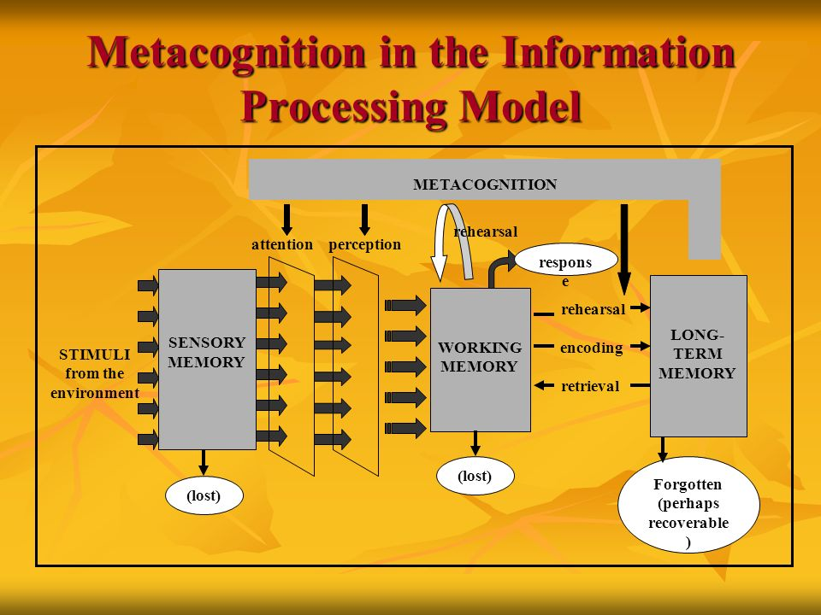](https://www.google.com/url?sa=i&rct=j&q=&esrc=s&source=images&cd=&ved=2ahUKEwjd89yb96fiAhWLdt8KHa1NC0IQjRx6BAgBEAU&url=https://slideplayer.com/slide/8096707/&psig=AOvVaw2xthMfFlTPPeIGdPuZIn2G&ust=1558366891994454)

|  |  |
| --- | --- |
| **STIMULI**  A key variable for IP (information processing). A STIMULUS is a reason or enticement for learning Stimulus must be clear and concise. The stimulus may be a question, a problem, or a process direction. | **REHEARSAL**  In order to “hang onto” the learning, the learner must rehearse the information. It is best to do this orally using language to support the learner’s ability to paraphrase, put the learning into familiar language**.** |
| **SENSORY MEMORY**  The first receptor/receiver of the stimulus. If the stimulus is incomplete, incoherent, or too complicated, the student cannot attend to the stimuli and the input is lost. | **ENCODING**  **Encoding** is the crucial first step to creating a new memory. Piaget calls this assimilation. The learner translates the perceived new information into a construct that can be stored and recalled later from short-term or long-term memory. Mnemonic devices support encoding. |
| **ATTENTION**  The learner must selectively attend to a stimulus that activates the sensory memory. The learner filters the important part of the stimulus in the form of a direction, question, or statement and the brain starts to activate the schema that the learner has in place. | **RETRIEVAL**  The ability to recall information from either working or long-term memory. Retrieval may not happen immediately, and the learner may need cues in order to retrieve and recall. |
| **PERCEPTION**  **Perception is** an unconscious **process. The learner** takes in sensory **information** from the environment and uses that **information** to construct a version of reality. **The main influence on perception is** past experiences. | **LONG TERM MEMORY**  Linking new knowledge explicitly to schema and knowledge already in the brain is vital to what is called synaptic consolidation – consolidating and integrating new information with memory by attending to the complexity of building schema. |
| **WORKING (short term) MEMORY**  The brain stores initial perception and learning for a short time, as the learner becomes aware of the learning through different representations, the learner processes information and starts to attach the new information to the schema already present in the brain. | **METACOGNITION**  **Metacognition** is thinking about one's thinking **processes** such as study skills, best ways to learn, memory capabilities, and the ability to monitor learning. An often-overlooked part of learning, if learners actually attend to how they learned, they are more like to self-regulate and take charge of their learning. |

**Loving Learning Theory Carnival**

Monday, July 22

7:15-9:30 pm

**PROTOCOL**

**BOOTH 2**

**Constructing Meaning**

|  |  |
| --- | --- |
| **Learning GOAL:**  **Participants access their prior knowledge to make sense of a group of related artifacts and collaboratively construct an understanding of the significance of those artifacts.** | |
| **Directions**   1. **Observe the poster of constructivism.** 2. **Directions:**     1. **Divide into groups of three or four.**    2. **Observe each individual artifact**       1. **What questions do you have about each artifact?**       2. **What personal connections might you have to the artifacts?**       3. **What is the purpose or use of each artifact?**       4. **How are the artifacts related?**    3. **As a group, create a profile of the artifacts** 3. **To debrief, return to the constructivist image and discuss how this lesson incorporated both social and cognitive constructivism.** 4. **STAMP/GIVE STICKER (?) the CARNIVAL BOOKLET** | |
| **Activities**   1. **The group observes the poster of constructivism. Ask: What do you observe about social and cognitive constructivism?** 2. **Each group gets an artifact bag to observe and discuss** 3. **Groups discuss artifacts and prepare summaries.** 4. **Group discusses how this represents constructivism and why we need this theory in our understanding of learning. What kind of learning does constructivism represent and why is it important for our students** | **Materials**   * **Poster of Constructivism** * **Bag of artifacts** |

[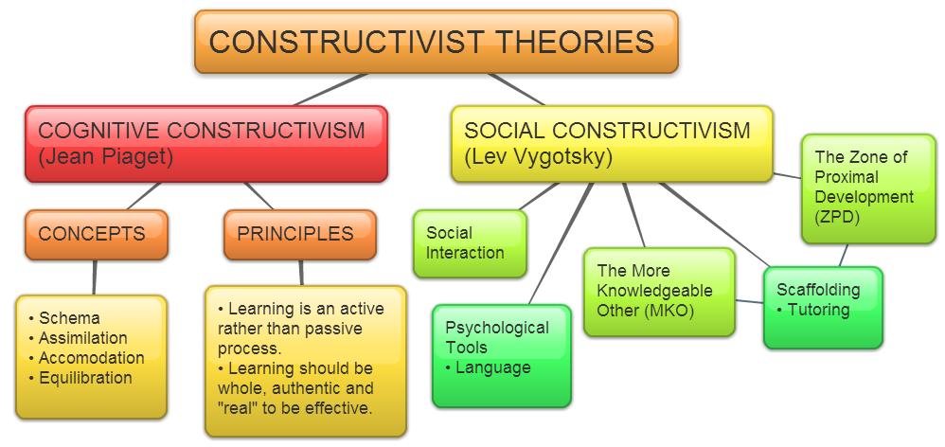](https://owelpapel.wordpress.com/tag/notes-and-resources/)

**LOVING Learning Theory Carnival**

Monday, July 22

7:15-9:30 pm

**PROTOCOL**

**BOOTH 3**

**What’s Got to Do with It?**

|  |  |
| --- | --- |
| **Learning GOAL:**  **Participants increase their knowledge of food deserts, place and meta-affective and social emotional learning by reflecting on their affective skills with peers** | |
| **Directions**   1. **Choose a partner and discuss your current knowledge and thinking about social emotional learning.** 2. **Watch the Clint Smith’s rap about his students and pay attention to your own feelings as you watch the video.** [**https://www.youtube.com/watch?v=saREW_BfxwY**](https://www.youtube.com/watch?v=saREW_BfxwY) 3. **With you partner, reflect on the following**    1. **Your own feelings and emotions as you watched the video**    2. **New understandings about food deserts, the importance of place, and the relationship between place, food and health**    3. **How your feelings and emotions contributed to your learning**   **Each partner has two minutes to present their thinking and the switch. For this conversation use Appreciative Listening strategies:**   * 1. **Face each other**   2. **As your partner is talking don’t interrupt**   3. **Maintain eye contact**   **Take two minutes to discuss the relationship between emotion and learning that took place as you watched the video and debriefed.**   1. **To debrief, use the model below to talk about the elements of SEL that are present in this activity and how your learning was supported by a peer.** 2. **STAMP/GIVE STICKER (?) the CARNIVAL BOOKLET** | |
| **Activities**   1. **The group divides into pairs and activates prior knowledge of SEL and affective learning.** 2. **Each pair watches the video about food deserts and place.** 3. **Pairs discuss the relationship between emotions and what they learned about food deserts and place.** 4. **Group uses visual to discuss elements of social emotional learning and how those elements played out in their experience.** | **Materials**   * **Poster of SEL model from CASEL** * **Computer to play video** |

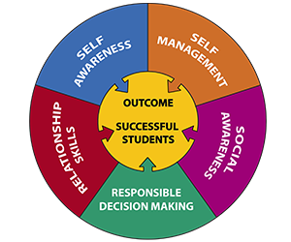

**LOVING Learning Theory Carnival**

Monday, July 22

7:15-9:30 pm

**PROTOCOL**

**BOOTH Four**

**Who Needs Vygotsky?**

|  |  |
| --- | --- |
| **Learning GOAL:**  **Participants increase their knowledge of abolitionism and learning theory by engaging in a Vygotskyan process of intersubjectivity with peers.** | |
| **Directions**   1. **Observe poster of constructivism and zero in on VYGOTSKY** 2. **Direction: We are going to pick cards of abolitionists and discuss in pairs. After we finish, we are going to talk about the components of Vygotskyan theory that are represented by the activity.**   ***First let’s activate prior knowledge -- ASK: What do you currently know about abolitionism or abolitionists? Discuss in pairs.***   1. **Demonstrate by choosing one person as partner and summarizing one card and asking questions to support the person’s learning like**   **Example (Samuel Ringgold Ward)**  *Samuel Ward was born an enslaved person and was able to escape with his parents and move to NY. Like Frederick Douglass, he was an orator who supported the anti-slavery cause, eventually becoming a pastor and later involved in the Anti-Slavery society. Fear of becoming re-enslaved, he moved to Canada and then Jamaica where he died at age 49 in 1866.*  **What facts about Ward are most of interest to you?**  **What would you like to know more about?**   1. **Every person picks a card, reads and formulates a summary.** 2. **Pair persons a second time and have them discuss information from card.** 3. **To debrief, talk about the elements of Vygotsky that are present in this activity and how your learning was supported by a peer.** 4. **STAMP/GIVE STICKER (?) the CARNIVAL BOOKLET** | |
| **Activities**   1. **The group observes the poster of constructivism. Ask: What do you observe about Vygotsky’s contribution to constructivism? Activate prior knowledge by asking question.** 2. **Each person gets a card and prepares summary.** 3. **Pairs discuss summaries.** 4. **Group discusses how this represents Vygotsky and why we need this theory in our understanding of learning – particularly intersubjectivity (social interaction), using paraphrasing and language to support learning, and how this is social construction of knowledge.** | **Materials**   * **Poster of Constructivism** * **Abolitionist CARD DECK** |

[](https://owelpapel.wordpress.com/tag/notes-and-resources/)

**LOVING Learning Theory Carnival**

Monday, July 22

7:15-9:30 pm

Booth 5

**PROTOCOL**

**BOOTH 5**

**PIAGET’s PENDULUM**

|  |  |
| --- | --- |
| **Learning GOAL:**  **Participants collaboratively design and conduct pendulum experiment and reflect on how the experiment relates to cognitive constructivism and how learners at different stages of development might approach this experiment.** | |
| **Directions**   1. **Observe the poster of constructivism. Pay close attention to the cognitive constructivism side of the poster. Also observe the second poster of Piaget’s four stages** 2. **Directions:**     1. **Work in pairs to conduct an experiment. Your task is to determine which factor is the most important in determining the speed of swing of the pendulum.**    2. **Begin the experiment by making a hypothesis. What factor is most important in determining the speed of swing:**       1. **Length of rope**       2. **Weights**       3. **Force of the push**    3. **As a group, design your approach to the experiment. How will you test your hypothesis?**    4. **Conduct your experiment.**    5. **What are your conclusions?** 3. **To debrief:**    1. **Return to the constructivist image and discuss how this lesson incorporated the concepts and principles of cognitive constructivism.**    2. **Return to the second image. What might be some differences in the way students in the concrete operational stage and students in the formal operational stage approach this experiment?** 4. **STAMP/GIVE STICKER (?) the CARNIVAL BOOKLET** | |
| **Activities**   1. **The group observes the poster of cognitive constructivism and the poster of Piaget’s four stages. Ask: What do you observe about cognitive constructivism? About the four stages?** 2. **Each group gets materials to conduct the pendulum experiment.** 3. **Groups hypothesize and then conducts experiment.** 4. **Group determines conclusions.** 5. **Group discusses how this represents cognitive constructivism and why we need this theory in our understanding of learning. What kind of learning does cognitive constructivism represent and why is it important for our students** | **Materials**   * **Pendulum Frame** * **String – 3 different lengths** * **Washers – 5 different washers** |

[](https://owelpapel.wordpress.com/tag/notes-and-resources/)

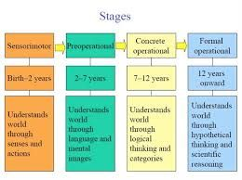

**LOVING Learning Theory Carnival**

Monday, July 22

7:15-9:30 pm

**PROTOCOL**

**BOOTH 6**

**Multi-Modal Bruner**

|  |  |
| --- | --- |
| **Learning GOAL:**  **Participants can articulate multiple modes of representation according to Bruner’s kinesthetic, iconic (visual) and symbolic (language)** | |
| **Directions:**   1. **We are here to think about multiple modes of representation as important to learning. Later in the week, we will touch on this again with the Universal Design for Learning. This is more than learning styles; this is supporting students to use different modes or representations to develop a concept…in this case, the importance of circles in our lives.** 2. **Observe circle images. What are your observations** 3. **Watch the video and talk about observations.** [**https://www.youtube.com/watch?v=pNe6fsaCVtI**](https://www.youtube.com/watch?v=pNe6fsaCVtI) 4. **Pose the question: *What message about circles can you infer from these two images?*** 5. **Read the poem aloud and have pairs choose a favorite word, line or phrase. Pose the question: *What other messages about circles does the poem convey?*** 6. **Then in two groups of 5, the groups should embody the poem and present them.** 7. **If time, discuss how this relates to the three modes of Bruner’s representations.** | |
| **Activities**   1. **The group observes circle images (video and poster). Talks about observations. *What message about circles can you infer from these two images?*** 2. **Read the poem aloud and the pairs share favorite phrase or line. *What message about circles does the poem convey?*** 3. **Then group decides how to embody the poem** 4. **Then discuss how each form (enactive-kinesthetic; iconic-visual; and symbolic-language enhanced your learning.** | **Materials**   * **Poster of Circle Images** * **Poem** |

[[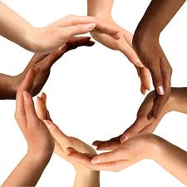](https://www.google.com/imgres?imgurl=https://utahvalley360.com/wp-content/uploads/2014/11/Circles-Community-Action.jpg&imgrefurl=https://utahvalley360.com/2014/11/20/circles-bridges-helping-people-poverty-community-mentors/&docid=9rf6ImgMdxMSiM&tbnid=CBHRbcMAlRKObM:&vet=10ahUKEwjMvYezr7LiAhWCTN8KHdjAD7cQMwhpKA0wDQ..i&w=600&h=600&bih=734&biw=1324&q=people%20in%20circles&ved=0ahUKEwjMvYezr7LiAhWCTN8KHdjAD7cQMwhpKA0wDQ&iact=mrc&uact=8)](https://www.google.com/imgres?imgurl=https%3A%2F%2Futahvalley360.com%2Fwp-content%2Fuploads%2F2014%2F11%2FCircles-Community-Action.jpg&imgrefurl=https%3A%2F%2Futahvalley360.com%2F2014%2F11%2F20%2Fcircles-bridges-helping-people-poverty-community-mentors%2F&docid=9rf6ImgMdxMSiM&tbnid=CBHRbcMAlRKObM%3A&vet=10ahUKEwjMvYezr7LiAhWCTN8KHdjAD7cQMwhpKA0wDQ..i&w=600&h=600&bih=734&biw=1324&q=people%20in%20circles&ved=0ahUKEwjMvYezr7LiAhWCTN8KHdjAD7cQMwhpKA0wDQ&iact=mrc&uact=8)

[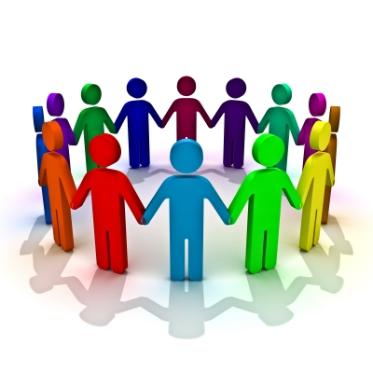](https://www.google.com/url?sa=i&rct=j&q=&esrc=s&source=images&cd=&ved=2ahUKEwiT6qvTr7LiAhVjg-AKHapaBsAQjRx6BAgBEAU&url=https://endtimesprophecyreport.com/2014/05/06/prayer-circles-another-pagan-practice-in-the-church/&psig=AOvVaw2nQaS1AYEozA3faOnFRZtc&ust=1558725575860525)

The Circle’s Web

Weren’t we meant

To stand in circles

Feel the round

The curve

The energy inward

The momentum,

Next, across

The smiling eyes

Pick up the dangling word

Finish or help

Hold up, high five

Shoulder the sagging

Join hands

For grace

The glance of glee

The skip of laughter

The push of angst

The wave of mellow

Cradling the spell of memory.

Lynda Tredway, 1996

**Loving Learning Theory Carnival**

Monday, July 22

7:15-9:15 pm

**PROTOCOL**

**BOOTH 7**

**Story-Making: The Dinner Table**

|  |  |
| --- | --- |
| **Learning GOAL:**  Through the process of “story-making”, participants will dive deeper into their Sites of Struggle, Sites of Strength, and Sites of Survivance to explore how culture influences how we learn. | |
| **Directions**   1. Draw your family gathering/dinner. Take note of the:    1. “time”, e.g., time of year, time of day”, when you were a child – today, etc.    2. “place”, e.g., indoors/where, outdoors/where, elements of the environment    3. “who is there”, e.g., family, extended family, friends, guests, etc.    4. Clothing, food, drinks, activities, conversations 2. Paired Sharing & unpacking the event to better see/understand the “cultural” aspects of the gathering 3. Debrief Queries: “How do elements of our society and your family/lineage culture affect your learning sites?” “How can you engage social norms and cultural stories of students to support, strengthen their learning experience?” 4. Stamp in Carnival Booklet. | |
| **Activities**   1. Everyone draws their family gathering/dinner portraiture. 2. Paired discussion allows participants to unpack their drawing and determine how socio-cultural aspects of our own life stories influence how we learn: our struggles, our strengths, and our enduring survivance. 3. The group discusses using the 2 probe queries as catalysts. | **Materials**  8 x 10 or 11 x 14 paper  Crayons |

**Loving Learning Theory Carnival**

Monday, July 22

7:15-9:15 pm

Booth 8

**PROTOCOL**

**BOOTH 8**

**Three Brains: Each Plays a Part**

|  |  |
| --- | --- |
| **Learning GOAL:**  **Participants can explain the functions of the three parts of the brain and how these functions can affect learning** | |
| **Directions**   1. **Observe the blank brain drawing.** 2. **The balloons are over the cards that tell parts of the brain. The task is to use darts to break the balloon and the card will appear.** 3. **The participant reads the card aloud and places on the brain drawing if a part of the brain or on the sequence at the bottom of the drawing if a part of the process of learning.** 4. **Proceed to break all balloons and place all cards.** 5. **To debrief, talk about the importance of understanding how the brain works.** 6. **STAMP/GIVE STICKER (?) the CARNIVAL BOOKLET**   **Note: The facilitator has to quickly change the cards back under new balloons for each group.** | |
| **Activities**   1. **The group observes the poster of the brain.** 2. **Each person in turn has a chance to throw a dart at the dart board.** 3. **Each person reads aloud and places the card on the poster of the brain (if s/he knows) where to do that.** 4. **Repeat until all balloons are burst and cards placed.** 5. **Group discusses the importance of knowing about the brain to learning** | **Materials**   * **Poster of Brain Drawing** * **CARDS** * **Balloons** * **Darts** * **Cork Board** * **Velcro** |

|  |
| --- |
| **AMYGDALA**  **A small almond-shaped structure inside the limbic system, which includes thalamus and hippocampus. All regulators of how we react. Hammond (2015) calls the amygdala the “guard dog” because it is on guard for anxiety. The amygdala can release cortisol that goes straight to the thalamus sending anxiety waves through the brain when we sense danger (like a microaggression). These interrupt cognitive waves and the ability to be fully attentive or process information.** |
| **THALAMUS**  **The thalamus (from Greek θάλαμος, "chamber") is a large mass of gray matter in the limbic system of the brain with several functions: relaying of sensory signals, including motor signals to the cerebral cortex, and the regulation of consciousness, sleep, and alertness. Hammond (2015) calls the thalamus the “brain’s communication dispatch hub” because all incoming sensory information has to pass through the thalamus. However, if the brain senses danger and the amygdala releases cortisol, that can interrupt the thalamus’ ability to take in information.** |
| **HIPPOCAMPUS**  **The hippocampus is a small, curved formation in the brain that plays an important role in the limbic system. It is involved in the formation of new memories and is also associated with learning and emotions. Because the brain is lateralized and symmetrical, you actually have two hippocampi. In short term memory, you can hold information 5-20 seconds. If you do not process it in some way, you lose it. In working memory, you can hold information for up to 20 minutes, allowing you to send signals to your brain schema to re-imagine how new information fits with old**. |
| **PREFRONTAL CORTEX**  **The prefrontal cortex (PFC) is the cerebral cortex covering the front part of the frontal lobe. This brain region has been implicated in planning complex cognitive behavior, personality expression, decision making, and moderating social behavior. Executive function exists in the neo or prefrontal cortex. Hammond (2015) says that “executive functioning controls planning, abstract thinking, organization and self-regulation”** |
| **RETICULAR ACTIVATING SYSTEM (RAS)**  The reticular activating system is in the reptilian part of the brain, just above the brain stem, responsible for alertness and attention. “The RAS scans our environment 24/7 for novelty that signals changes, any possible threats to one’s social status, physical survival or strong emotions (bodily harm, humiliation, microaggressions) or rewards (food, friendship). It sends reports to the amygdala”, which can then interrupt the thalamus (Hammond, pp. 38-39). |
| **REPTILIAN BRAIN**  The oldest part of the brain, the reptilian brain has three parts. The brain stem **controls the body's vital functions such as heart rate, breathing, body temperature and balance. T**he cerebellum **receives information from the sensory systems, the spinal cord, and other parts of the brain and then regulates motor movements. The cerebellum coordinates voluntary movements such as posture, balance, coordination, and speech, resulting in smooth and balanced muscular activity. The RAS (reticular activating system) mediates overall level of consciousness.** |
| **WORKING MEMORY**  Working memory is “where the brain works to connect new information to old knowledge in order to turn facts, figures, dates, concepts, or skills into something that has meaning and relevance to the learner” (Hammond, p. 40). This stores information currently in use for up to 20 minutes so that the learner can process and hopefully practice enough to get into long term memory by connecting to schema in which the brain stores information in an organized way to facilitate remembering at a later date. |
| **SHORT TERM or SENSORY MEMORY**  Information (stimuli) enters short term for a short time – 5-20 seconds, but it is not a processing center. Unless the learner interacts with the information, the learner “loses” the information. Learning (or quickly forgetting) a phone number is an example of how this works. Being able to attend depends on the limbic system and the ability of the thalamus to engage its ability to take in and use information. |
| **LONG TERM MEMORY**  **Two types of long-term memory include procedural memory, how to do things, and declarative memory, facts, general knowledge, and personal experiences.**  **Information stored in long-term memory is first held in the hippocampus and then transferred to the areas of the cerebral cortex involved in language and perception for permanent storage.** |
| **THREE PARTS OF THE BRAIN**  The brain parts developed in humans over time. The reptilian stem houses the brain stem, the cerebellum, and the RAS (reticular activating system). The limbic system is a layer of the brain or the emotional part of the brain is just above the reptilian stem and present only in mammals. Finally, the prefrontal or neocortex is a slower “processor” but houses the executive function of the brain. |